To Enable VBA in Excel, please follow the steps below:

1. Click on File from the top drop down menu. Tick ‘Add-ins’.

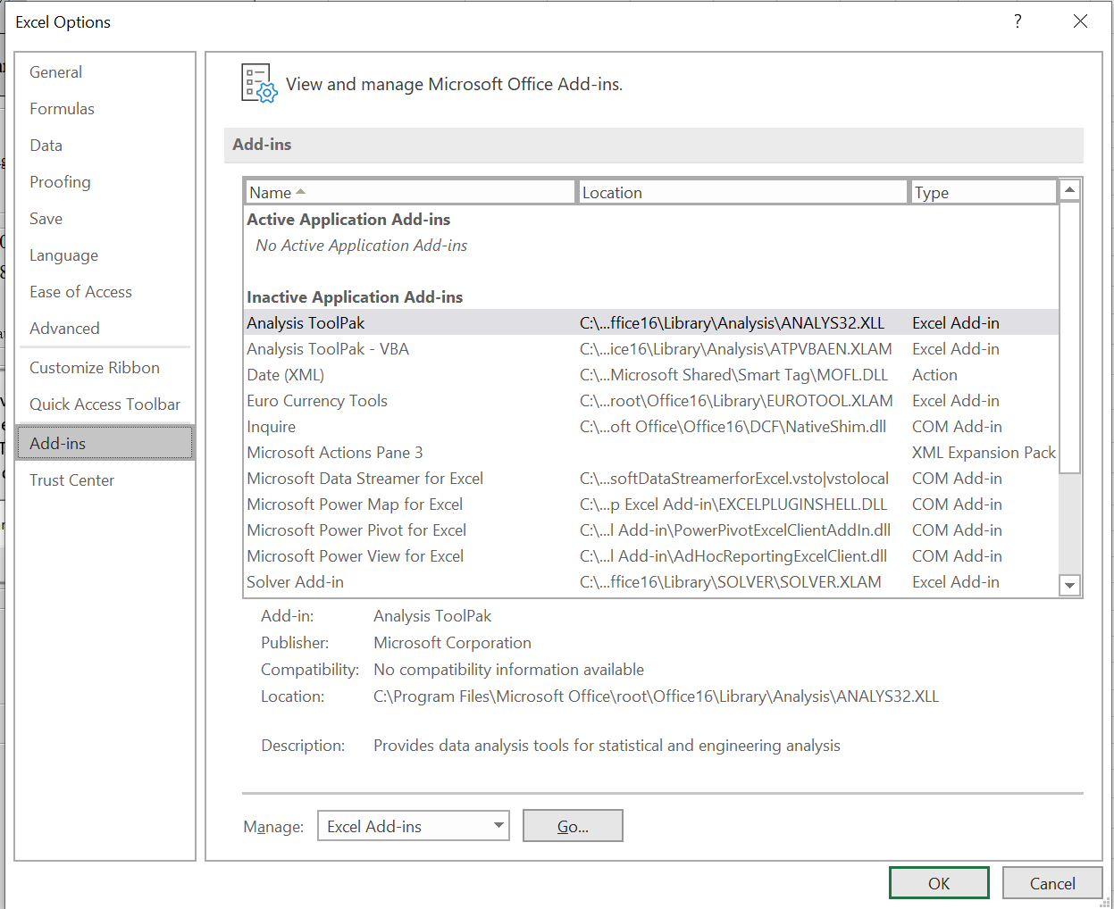

1. Press ‘Go’, then Press ‘OK’.



In the Excel Options Dialog box, click on Add Ins

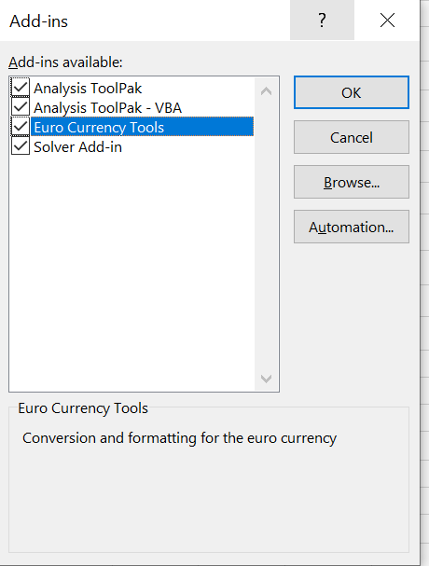

1. In the Excel Options Dialog box, click on Add Ins



Tick the boxes above and then click OK.